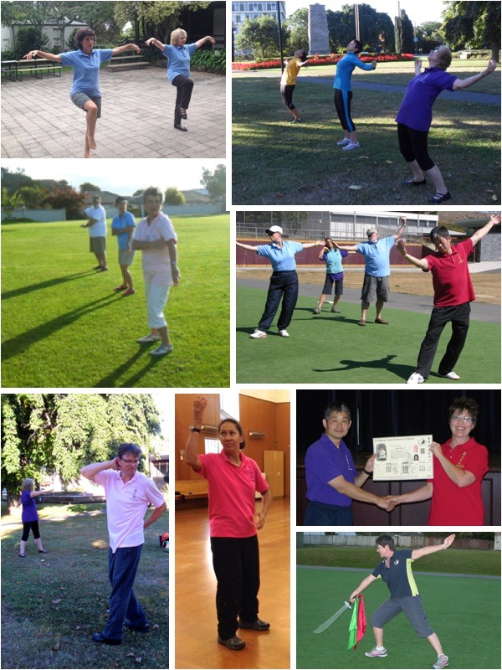

**Wild Goose Qigong**

*More than just exercise*

**Kunlun Dayan Qigong** is a traditional Chinese health skill promoting *health & longevity* with a focus on:

* Relaxation & energy from within
* Boost to immunity from colds etc.
* Better balance & coordination
* Flexibility; easier joint & back movement

**Chun Yuen Quan**

a Shaolin fist, classes are also available, Think of it as a Kung fu for fitness!

Authentic lineage & skillful teaching with Sifu Jennifer Leaf, Senior Instructor authorised by Tse Qigong Centre

**Hawke’s Bay Classes**

2087 Pakowhai Road, Pakowhai

Between Napier & Hastings

**Term 1 2020 Begins Wednesday 22 January**

**Term fees, Casual class payments, Seminars, Private tuition available**

*Begin any time. However, if you prefer, sign up for next introductory course*

Contact 021 298 6740 [www.wildgooseqigong.nz](http://www.wildgooseqigong.nz)

**More information on reverse**

**What is it?**

**Wild Goose Qigong & Chun Yuen Quan Information**

Qigong means energy work - There are hundreds of styles of Qigong - One Qigong is not like the other.

Wild Goose Qigong or Kunlun Dayan Qigong is an authentic traditional Chinese health skill which began its journey to New Zealand over 1800 years ago from the Kunlun Mountain range in Northwest China. Kunlun Dayan or the Bar-headed Goose is known for its longevity and its beauty can be seen throughout many of the forms. Pronounced *“chee-gong”.*

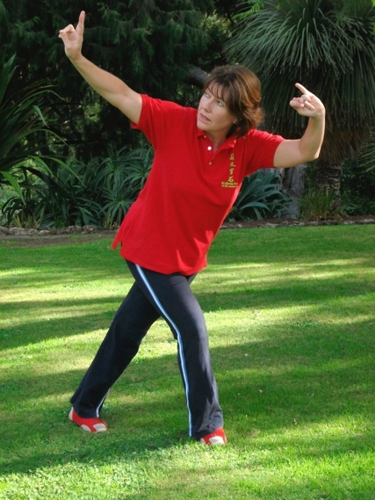

**Is it like Tai Chi?**

The movement is similar and both are both are good for your health. The energy is different; Tai Chi is a martial art. Understanding the bodies energy will aid both skills.

**Why do we practice Wild Goose Qigong?**

To improve our health - body, mind & spirit. There are a number of forms within the Wild Goose system. Even though they all have numerous benefits, some will have a focus on specific aspects of health.

The movements are gentle on the body, move in all different directions, and by doing this, we stimulate the organs and channels in the body and aid in removing blockages.

**Who should do Qigong?** Anyone can practice Qigong.

For those that are already quite active Qigong promotes systemic balance, relaxation, and clarity of thought.

For those that are inactive it provides a gentle doable exercise regime in a supportive atmosphere where everyone works at their own pace.

**What are the benefits?**

There are numerous benefits with regular practice. Think of Qigong as a tune-up allowing bodily systems to function more efficiently; increasing prevention and improving well-being.

**How do I get started?**

You can start any time by attending weekly classes, signing up for a seminar, or taking a private lesson. As with any skill, commitment to truly “giving it a go” e.g. trying it for a term will give you a better idea of what Wild Goose Qigong is all about. Taking time to practice outside of class on a regular basis will help grow your Qigong skill.

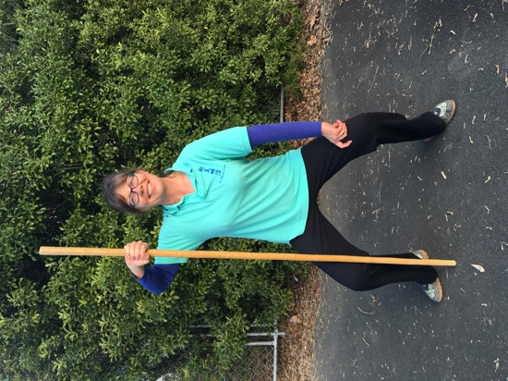**What is Chun Yuen Quan?**

Chun Yuen Quan is Shaolin Kung fu that has come down through the Beijing Opera. Students learn martial forms that are excellent for joints and posture, lift the spirit and heat the body. This skill is faster-paced than the Qigong classes (more yang), but still adaptable to a range of abilities.

**Who will I be learning from?**

Jennifer Leaf, a senior instructor with the Tse Qigong Centre, has been teaching these skills since 2005. Grand Master Tse Wei Jing (Michael Tse), originally from Hong Kong, requires Tse Centre authorised instructors to participate in regular training and testing to ensure the skills are passed on with continuing integrity.

**What would be expected of me as a student?**

We are not regimented, but expect respect for the skill and the opportunity to learn it. Give yourself the time to come to class, dress comfortably, and progress at your own pace. Inform your Sifu (teacher) if you cannot attend. As Great Grandmaster Yang Meijun said, “All practice with one heart together.”

**Fees?\*** Pay by term or casual class fee. For the most current schedule – downloadable from the website or email me to request a copy. *\*After trying out class for a determined time you need to pay your ANNUAL MEMBERSHIP FEE to the Tse Qigong Centre which supports these traditional skills. Cost is $60 ($100 for family at same address). This is due before your 7th Beginner class, 4th Qigong and/or Chun Yuen class, or second private lesson and each year during month you originally became a member. Membership Includes class shirt, seminar discounts, selected merchandise, and the opportunity to continue studying this amazing skill.*